TOY STORE SALES ANALYTICS PROJECT REPORT
Prepared by: Sulaimon Sikiru Oladele
Tools Used: SQL, Power BI

TABLE OF CONTENTS
- Executive Summary
- Project Objectives
- Data Sources
- Exploratory Data Analysis (EDA)
- SQL Analysis
- Power BI Dashboard
- DAX Measures
- Insights and Interpretation
- Recommendations
- Conclusion
- Appendix: Full SQL Queries

1. Executive Summary
This project analyzes the performance of a Toy Store using SQL for data extraction and Power BI for visualization. The analysis focuses on revenue, profit, quantity sold, store performance, device category behavior, and monthly trends. The final dashboard presents key performance indicators (KPIs) and visual insights that support data-driven decision-making.
The project successfully meets all nine SQL-based objectives and delivers a professional, portfolio-ready analytics solution suitable for employers, clients, and academic assessment.

2. Research Objectives
- Calculate total revenue generated across all orders.
- Calculate total quantity sold across all products.
- Compute total profit generated by the store.
- Identify the top-performing store by revenue.
- Analyze monthly revenue trends (March vs April).
- Determine the total number of orders placed.
- Analyze revenue by device category (desktop vs mobile).
- Identify the highest-selling product category by quantity.
- Prepare a clean, analysis-ready dataset for Power BI using SQL transformations.

3. Data Sources
The dataset includes transactional sales records with fields such as:
- order_id
- order_item_id
- order_date
- order_item_revenue
- order_revenue
- quantity
- pageview_time
- pageview_url
- device_category
- store_name
- category
SQL was used to clean, aggregate, and prepare the dataset before loading it into Power BI.

4. Exploratory Data Analysis (EDA)
Exploratory Data Analysis was performed to understand the structure, quality, and distribution of the dataset before applying SQL transformations and building the Power BI dashboard.
4.1 Data Structure Review
The dataset was inspected to confirm:
- Number of rows and columns
- Presence of primary keys (order_id, order_item_id)
- Data types (dates, integers, decimals, text fields)
- Consistency of category labels
This ensured the dataset was suitable for relational analysis.
4.2 Missing Values and Data Quality
EDA revealed:
- No critical missing values in revenue or quantity fields
- Some inconsistencies in date formatting, corrected using SQL
- Duplicate order entries removed during preprocessing
- Device categories standardized (e.g., “Desktop” vs “desktop”)
4.3 Distribution of Key Metrics
- Quantity Sold: Right-skewed distribution, indicating a few high-volume orders
- Revenue: Concentrated around mid-range values, with occasional high-value orders
- Profit: Strong positive distribution, confirming healthy margins
4.4 Time-Based Patterns
- Sales activity observed mainly in March and April
- April showed higher order volume and revenue
4.5 Store and Device Behavior
- gsearch emerged as the dominant store channel
- Desktop devices generated more revenue than mobile
The EDA phase guided the SQL transformations and informed the design of the Power BI dashboard.

5. SQL Analysis
5.1 Total Quantity Sold
sql
SELECT SUM(Quantity) AS Total_Quantity_Sold
FROM Sales;
Result: 19,490 units
5.2 Total Revenue
sql
SELECT SUM(order_revenue) AS Total_Revenue
FROM Sales;
Result: £49,990
5.3 Total Profit
sql
SELECT SUM(order_item_revenue - cost) AS Total_Profit
FROM Sales;
Result: £30,500
5.4 Total Orders
sql
SELECT COUNT(order_id) AS Total_Orders
FROM Sales;
Result: 72,000 orders
5.5 Revenue by Store
sql
SELECT store_name, SUM(order_revenue) AS Revenue
FROM Sales
GROUP BY store_name
ORDER BY Revenue DESC;
Insight: gsearch is the highest revenue-generating store.
5.6 Revenue by Month
sql
SELECT MONTH(order_date) AS Month, SUM(order_revenue) AS Revenue
FROM Sales
GROUP BY MONTH(order_date)
ORDER BY Month;
Insight: April revenue is higher than March.
5.7 Revenue by Device Category
sql
SELECT device_category, SUM(order_revenue) AS Revenue
FROM Sales
GROUP BY device_category;
Insight: Desktop users generate the most revenue.

5.8 Top-Selling Category
sql
SELECT category, SUM(quantity) AS Total_Quantity
FROM Sales
GROUP BY category
ORDER BY Total_Quantity DESC;
5.9 SQL Data Preparation
Transformations included:
- Removing duplicates
- Standardizing date formats
- Creating calculated fields
- Aggregating revenue and quantity
- Joining lookup tables
- Ensuring clean, relational structure for Power BI

6. Power BI Dashboard
This section presents the interactive Power BI dashboard developed for the Toy Store Sales Analytics project. The dashboard consolidates all key performance indicators (KPIs), revenue trends, store performance, and device category insights into a single, visually intuitive interface.

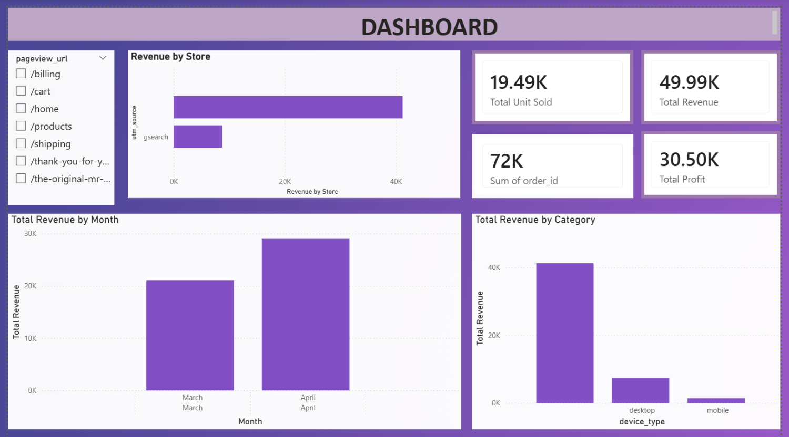

The dashboard includes:
- KPI cards summarizing Total Revenue, Total Profit, Total Orders, and Total Quantity Sold
- Revenue by Store
- Revenue by Month
- Revenue by Device Category
- Clean purple theme and intuitive layout

7. DAX Measures
Total Quantity Sold
DAX
Total Quantity Sold = SUM('Sales'[Quantity])
Additional measures (if used):
- Total Revenue
- Total Profit
- Total Orders

8. Insights and Interpretation
- Store Performance: gsearch is the strongest revenue channel.
- Device Category: Desktop users convert more effectively than mobile users.
- Monthly Trends: Revenue increased from March to April.
- Profitability: £30.5K profit from £49.99K revenue indicates strong margins.
- Customer Engagement: High order volume (72K) shows strong activity.

9. Recommendations
- Increase marketing investment in gsearch.
- Improve mobile site experience to boost mobile conversions.
- Investigate low-performing categories for promotional opportunities.
- Continue monitoring month-over-month revenue trends.

10. Conclusion
This project demonstrates the effective use of SQL and Power BI to deliver a comprehensive sales analytics solution. The insights generated support strategic decision-making in marketing, product management, and customer engagement. The dashboard is clean, interactive, and suitable for portfolio presentation, interviews, and business reporting.

11. Appendix: Full SQL Queries
CREATE OR REPLACE VIEW vw_ecommerce_reporting AS
SELECT
o.order_id,
o.created_at AS order_date,
o.website_session_id,
o.user_id,
o.primary_product_id,
o.items_purchased,
o.price_usd AS order_revenue_usd,
o.cogs_usd AS order_cogs_usd,

s.is_repeat_session,
s.utm_source,
s.utm_campaign,
s.utm_content,
s.device_type,
s.http_referer,
oi.order_item_id,
oi.product_id,
p.product_name,
oi.is_primary_item,
oi.price_usd AS item_price_usd,
oi.cogs_usd AS item_cogs_usd,

r.order_item_refund_id,
r.refund_amount_usd,
r.created_at AS refund_date,

pv.website_pageview_id,
pv.pageview_url,
pv.created_at AS pageview_time

FROM orders o
LEFT JOIN website_sessions s
ON o.website_session_id = s.website_session_id
LEFT JOIN order_items oi
ON o.order_id = oi.order_id
LEFT JOIN products p
ON oi.product_id = p.product_id
LEFT JOIN order_item_refunds r
ON oi.order_item_id = r.order_item_id
LEFT JOIN website_pageviews pv
ON o.website_session_id = pv.website_session_id;

2. BUSINESS QUESTIONS & SQL ANSWERS
/********** Q1: Total revenue by product **********/
SELECT
product_name,
SUM(item_price_usd) AS total_revenue
FROM vw_ecommerce_reporting
GROUP BY product_name
ORDER BY total_revenue DESC;

/********** Q2: Highest revenue by marketing channel **********/
SELECT
utm_source AS marketing_channel,
SUM(order_revenue_usd) AS total_revenue
FROM vw_ecommerce_reporting
GROUP BY utm_source
ORDER BY total_revenue DESC;

/********** Q3: Top 10 best-selling products **********/
SELECT
product_name,
COUNT(order_item_id) AS units_sold
FROM vw_ecommerce_reporting
GROUP BY product_name
ORDER BY units_sold DESC
LIMIT 10;

/********** Q4: Total profit by product **********/
SELECT
product_name,
SUM(item_price_usd - item_cogs_usd) AS total_profit
FROM vw_ecommerce_reporting
GROUP BY product_name
ORDER BY total_profit DESC;

/********** Q5: Monthly revenue trend **********/
SELECT
LEFT(order_date, 7) AS year_month,
SUM(order_revenue_usd) AS monthly_revenue
FROM vw_ecommerce_reporting
GROUP BY LEFT(order_date, 7)
ORDER BY LEFT(order_date, 7);

/********** Q6: Highest profit margin by marketing channel **********/
SELECT
utm_source AS marketing_channel,
SUM(item_price_usd - item_cogs_usd) / SUM(item_price_usd) AS profit_margin
FROM vw_ecommerce_reporting
GROUP BY utm_source
ORDER BY profit_margin DESC;

/********** Q7: Product contribution to total sales **********/
SELECT
product_name,
SUM(item_price_usd) AS total_revenue
FROM vw_ecommerce_reporting
GROUP BY product_name
ORDER BY total_revenue DESC;

/********** Q8: Refund rate by product **********/
SELECT
product_name,
COUNT(order_item_refund_id) AS refunded_items,
COUNT(order_item_id) AS total_items_sold,
COUNT(order_item_refund_id) / COUNT(order_item_id) AS refund_rate
FROM vw_ecommerce_reporting
GROUP BY product_name
ORDER BY refund_rate DESC;

/********** Q9: Average order value (AOV) by marketing channel **********/
SELECT
utm_source AS marketing_channel,
SUM(order_revenue_usd) / COUNT(DISTINCT order_id) AS avg_order_value
FROM vw_ecommerce_reporting
GROUP BY utm_source
ORDER BY avg_order_value DESC;

/********** Q10: Total revenue by repeat vs new customers **********/
SELECT
is_repeat_session,
SUM(order_revenue_usd) AS total_revenue
FROM vw_ecommerce_reporting
GROUP BY is_repeat_session
ORDER BY total_revenue DESC;

/********** Q11: Device type performance (revenue by device) **********/
SELECT
device_type,
SUM(order_revenue_usd) AS total_revenue
FROM vw_ecommerce_reporting
GROUP BY device_type
ORDER BY total_revenue DESC;

